**Problem Statements -**

**DASHBOARD 1: SUMMARY**

* **Key Performance Indicators (KPIs) Requirements:**

Total Loan Applications: We need to calculate the total number of loan applications received during a specified period. Additionally, it is essential to monitor the Month-to-Date (MTD) Loan Applications and track changes Month-over-Month (MoM).

Total Funded Amount: Understanding the total amount of funds disbursed as loans is crucial. We also want to keep an eye on the MTD Total Funded Amount and analyse the Month-over-Month (MoM) changes in this metric.

Total Amount Received: Tracking the total amount received from borrowers is essential for assessing the bank's cash flow and loan repayment. We should analyse the Month-to-Date (MTD) Total Amount Received and observe the Month-over-Month (MoM) changes.

Average Interest Rate: Calculating the average interest rate across all loans, MTD, and monitoring the Month-over-Month (MoM) variations in interest rates will provide insights into our lending portfolio's overall cost.

Average Debt-to-Income Ratio (DTI): Evaluating the average DTI for our borrowers helps us gauge their financial health. We need to compute the average DTI for all loans, MTD, and track Month-over-Month (MoM) fluctuations.

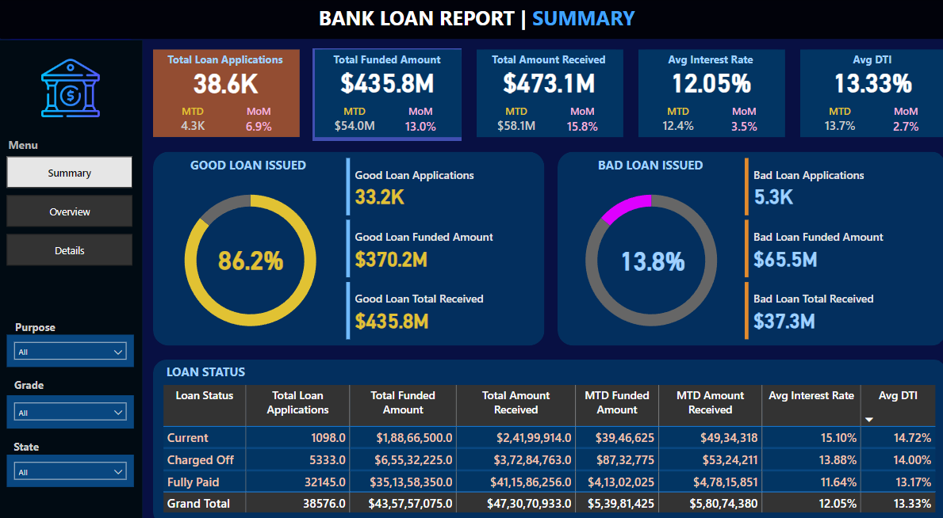

**DASHBOARD 2: OVERVIEW**

**CHARTS**

1. **Monthly Trends by Issue Date (Line Chart):** To identify seasonality and long-term trends in lending activities
2. **Regional Analysis by State (Filled Map):** To identify regions with significant lending activity and assess regional disparities
3. **Loan Term Analysis (Donut Chart):** To allow the client to understand the distribution of loans across various term lengths.
4. **Employee Length Analysis (Bar Chart):** How lending metrics are distributed among borrowers with different employment lengths, helping us assess the impact of employment history on loan applications.
5. **Loan Purpose Breakdown (Bar Chart): W**ill provide a visual breakdown of loan metrics based on the stated purposes of loans, aiding in the understanding of the primary reasons borrowers seek financing.

**Home Ownership Analysis (Tree Map):** For a hierarchical view of how home ownership impacts loan applications and disbursements.

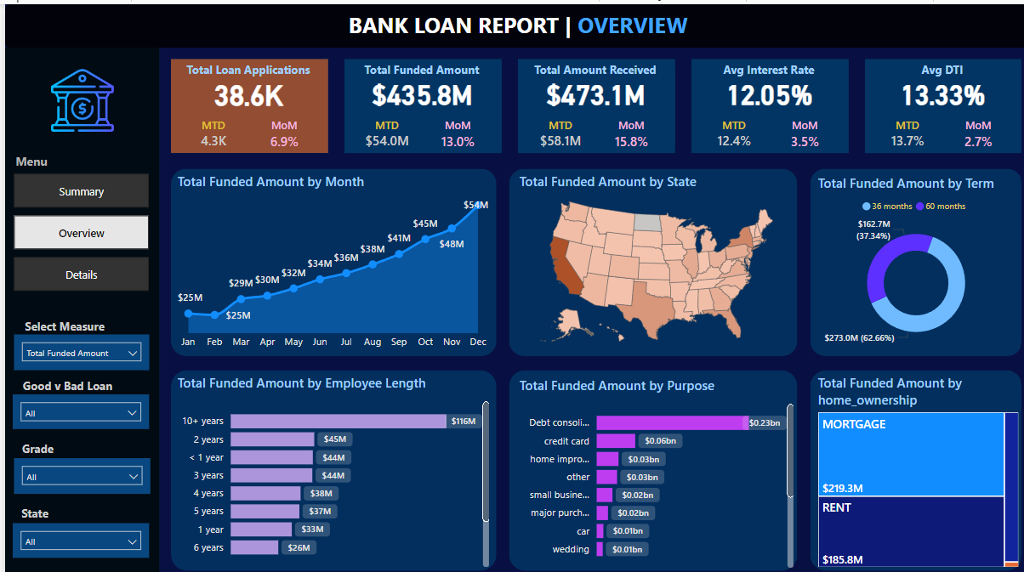

**DASHBOARD 2: Loan Report Analysis**

**Reasons for Analysing Bank Loan Data:**

Banks analyse loan data for several critical reasons:

Risk Assessment

: One of the primary purposes of analysing loan data is to assess the risk associated with lending to a particular individual or business. Banks use data to evaluate the creditworthiness of borrowers, predict default probabilities, and determine interest rates and lending terms.

Decision-making

: Loan data analysis supports the decision-making process when evaluating loan applications. Banks use data-driven models and algorithms to make informed lending decisions, such as approving or denying loan requests.

Portfolio Management

: Banks manage portfolios of loans, including mortgages, personal loans, and business loans. Data analysis helps banks monitor the health of these portfolios, identify underperforming loans, and optimize loan terms and pricing.

Fraud Detection

: Banks use data analysis to detect fraudulent loan applications and activities. Unusual patterns, inconsistencies, or discrepancies in loan data can trigger fraud alerts.

Regulatory Compliance

: Banks are subject to regulatory requirements that mandate the collection and reporting of loan data. Compliance with regulations such as the Home Mortgage Disclosure Act (HMDA) and the Know Your Customer (KYC) regulations requires data analysis and reporting.

Customer Insights

: Analysing loan data provides insights into customer behaviour, preferences, and needs. Banks can use these insights to tailor loan products and marketing strategies to specific customer segments.

Profitability Analysis

: Banks assess the profitability of their loan portfolios by analysing data related to interest income, loan origination costs, default rates, and collection efforts.

Market Research Credit Risk Management

: Banks continuously monitor and manage credit risk associated with their loans. Data analysis helps in setting risk management strategies, provisioning for potential losses, and stress testing loan portfolios.

Customer Retention

: Banks use data analysis to identify opportunities for retaining existing customers, such as offering loan refinancing options or additional financial products.

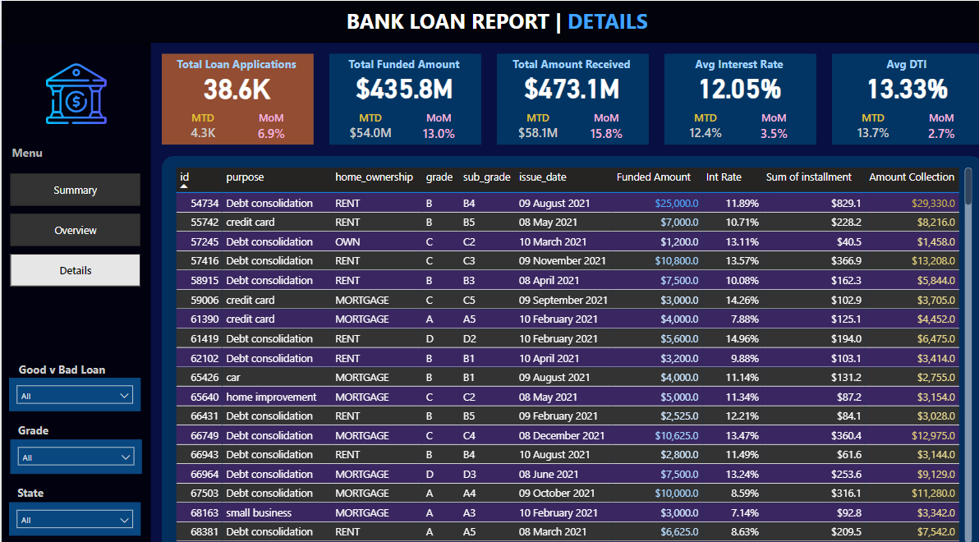

Thank-You!

-TheDataGuy6969